#72660 (formerly #72624)
NAME:
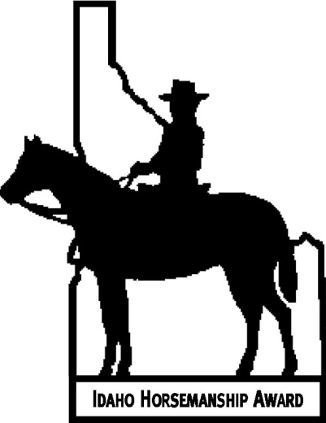
COUNTY:

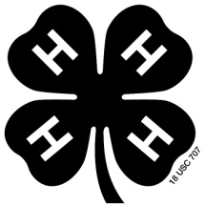
Idaho Horsemanship Award

- PURPOSE

Competition for the Idaho Horsemanship Award is a test of knowledge and skills in horsemanship. The purpose of the award is to honor the most talented youth riders in Idaho. It will test the youth’s riding ability and knowledge of equine subjects that are important to a well-informed and proficient horseperson. The Idaho Horsemanship Award not only sets a high level horsemanship goal for youth horseperson but also recognizes evidence of their citizenship and leadership abilities.

II-ELIGIBILITY

Any youth 14 years of age by January 1 and not more than 19 years of age during the calendar year and enrolled in an organized horse program may apply for this award. It is recommended the applicant has participated in the 4-H Horsemanship program, or other organized groups, such as Scouts, breed associations, pony clubs or others.

Applications must be made on the form on page 3 in this booklet. It will include a summary of the applicant’s leadership and citizenship activities.

The applicant must own or manage the horse used to compete for this award, a minimum of 120 days before the performance test. Type of equipment and tack (Western or English) the applicant uses is optional.


III-ADMINSTRATION

The Idaho Horsemanship Award program will be administered through the University of Idaho 4-H Youth Development office. The program will be conducted in each of the four Extension 4-H Districts by the District Horse Award chairperson and/or district Extension representative.

Application forms are available at each County Extension Office in the state. The contestant’s application form must be approved by his/her leader or instructor and returned to their County Extension Office.

All written and performance examinations for this award must be completed by October 1.

A head and shoulders, black and white photo of each winner must be sent to the University of Idaho 4-H Youth Development office by October 1.

NOTE TO APPLICANT: Please keep this booklet together. It will be your responsibility to take this booklet to each event. The judge will use the appropriate score sheet and sign it.

When all score sheets are completed, the booklet should be turned into your District Idaho Horsemanship Award chairperson or 4-H District Extension Representative.

IV-PROCEDURE

Competition for the award is divided into the following phases:

Application
- Application-Leadership and
Citizenship

Written Test
- Horse Husbandry-
Written test of knowledge 250 points

Performance
- Grooming and Handling-
Ground work-Western or English 150 points
- Equitation and Reining-
Riding activities in arena, Western
or English tests of skill 300 points
- Demonstration/Illustrated Talk 200 points

V-WRITTEN EXAMINATION

The written examination will be given only once a year in each Extension District. The examination will be given at a location designated by the appointed District 4-H Extension Representative.

For the date of the written exam in your area, see the University of Idaho Extension 4-H Youth Development website calendar at www.4h.uidaho.edu or contact the local county Extension office.

Those applicants passing the written examination with 70 percent or higher are eligible to proceed with the performance phase.

For a list of potential references for the written test, please see the University of Idaho 4-H Youth Development website at www.4h.uidaho.edu.

The application must be complete and legible to be eligible to receive the Idaho Horsemanship Award.

VI-PERFORMANCE PHASE

This phase includes Grooming and Handling, Equitation (either English or Western) and Practical Demonstration/Illustrated Talk. The Practical Demonstration topic should be about horses and/or horsemanship. A live animal may be used where facilities permit. Demonstrations will be given at the District 4-H Demonstration Contest, if applicable. These activities will be conducted only once each year at a designated time and place in each district.

For a list of these dates, see the University of Idaho Extension 4-H Youth Development website calendar at www.4h.uidaho.edu or contact the local county Extension office.

VII-FINAL AWARD

Youth who pass the performance phase with a score of 90 percent or higher, the written examination with a score of 70 percent or higher will be awarded the Idaho Horsemanship Award. The application must be complete and legible, and turned into the District 4-H Extension Representative to receive the award. The award consists of the Horsemanship Pin and the Horsemanship Certificate.

VIII-DONOR

Myrn Little began sponsoring this award in 1975 in memory of her husband, Andrew Little Jr. After his death, the family continues to sponsor the Idaho Horsemanship Award.

IX-ENDORSEMENTS

The Idaho Horsemanship Award is endorsed by the Idaho 4-H Youth Horse Council and University of Idaho Extension.

X-LETTERS OF APPRECIATION

Those who earn this fine award will want to express their appreciation. They should address correspondence to: Idaho Horsemanship Award, Andrew Little Jr. Memorial , c/o Mrs. Myrn Gosse, 4820 Adams Road, New Plymouth, ID 83655.

IDAHO HORSEMANSHIP AWARD
Application Form

County: Applicant #

Name: Age:
Mailing Address: Phone:
(Street or Route) (Town) (Zip)
Email Address:
Parent’s Name(s):
Club or organization:

Years of horsemanship training or 4-H Horse project work:

Summary of youth activities including leadership, citizenship, community, school, church, etc. (attach sheet if necessary):

Description of horse to be used:

I will have owned this horse for at least 120 days before the performance test? ______ Yes _____ No

Signature of Leader Signature of Applicant

Date
IDAHO HORSEMANSHIP AWARD
Scoring Sheet

Applicant Number District Name

Horse Husbandry Written Examination

Subjects included on the test:

Conformation and Skeletal Structure
Unsoundness, Diseases and Injuries
Nutrition
Breeds, Colors and Markings
Horsemanship and Management
Tack and Equipment
Equitation
Reproduction

Each question will be worth between 2 pts and 3 pts.

Total score possible (250 points) Your Score:

General Remarks:

Test Scorer’s Signature
IDAHO HORSEMANSHIP AWARD

Applicant Number District Name

Grooming and Handling
-Ground Work-

 |  | Points |  | Comments
 |  | Possible | Earned
Grooming: |  | 30 | _______
 | Grooming procedure, use of equipment, thoroughness of process, ease and manner of execution.
Care of Feet and Legs: |  | 30 | _______
 | Basic knowledge of anatomy, proper handling of feet and legs.
 | Cleaning of hooves, use of astringents (when and how).
 | Ease and manner of handling, common unsoundness
Handling: |  | 20 | _______
 | Approach, confidence, and manner of all aspects of handling and grooming
Saddling: |  | 25 | _______
 | Cleanliness of blanket and pad, saddle, bridle and other tack.
 | Position of saddle, tightness of girth, comfort of horse
Longe line: |  | 20 | _______
 | Horse works at three gaits in both directions. Minimum of effort on handler.
 | Longe whip allowed. Gloves required
Safety: |  | 25 | _______
 | Safe and secure manner in performing all phases of grooming and handling.
 | Total Score Possible | 150 | _______

Judge’s Signature
IDAHO HORSEMANSHIP AWARD

Applicant Number District Name

Western Equitation

 |  | Points |  | Comments
 |  | Possible | Earned
Appointments: |  | 25 | _______
 | Clothing, equipment, courtesy, and poise
Seat and Hands |  | 30 | _______
 | Seat, posture, head, legs (aids), hands, balance, distribution of weight
Performance |  | 30 | _______
 | Rail work: walk, jog, lope
Individual Performance
 | - Turn on fore hand, a one half turn in each direction. Pivot foot must stay within a 3-foot circle | 25 | _______
 | - One half turn on rear quarters in both directions. Pivot foot must stay within a 3-foot circle | 25 | _______
 | - Side pass, both directions. Formal crossover of legs not required-side step permissible | 25 | _______
 | - A correct balanced stop from a walk, jog, lope from a straight movement. Absolute stop—no movement in any direction | 20 | _______
 | - A correct balanced stop from a jog and lope in a circle. Absolute stop-no movement in any direction | 20 | _______
 | - Flying change of leads in a figure 8 at a lope. Lead change by aids not throwing horse into change by weight shift. | 25 | _______
 | - Flying change of leads on a straight-a-way. Change made without noticeable change of direction-a straight line change | 25 | _______
 | - Back the horse straight and in a circle. Controlled back: no resistance from horse and accomplished in circles, not squares, etc. | 25 | _______
 | - Dismount and mount | 15 | _______
 | - Oral questions | 10 | _______
Total score possible |  | 300 | _______

Judge’s Signature
IDAHO HORSEMANSHIP AWARD

Applicant Number District Name

English Equitation

 |  | Points |  | Comments
 |  | Possible | Earned
Appointments: |  | 25 | ______
 | Clothing, equipment, courtesy, and poise
Seat and Hands |  | 30 | ______
 | Seat, posture, head, legs (aids), hands, balance, distribution of weight
Performance |  | 30 | ______
 | Rail work-walk, walking trot, extended trot, canter, hand gallop. The horse is to perform all maneuvers, showing no resistance, on correct diagonals
Individual Performance
 | - Turn on fore hand, a one half turn in each direction. Pivot foot must stay within a 3-foot circle. | 25 | ______
 | - One half turn on rear quarters in both directions. Pivot foot must stay within a 3-foot circle. | 25 | ______
 | - Leg yield, both directions. Horse must be moving forward and show no resistance. Leg yields must be performed in both directions at the walk and at the trot. | 25 | ______
 | - A correct balanced halt on the straight-a-way. Horse should halt through the walk and the trot coming to a square stop and showing no resistance. The halt should be performed from the walk, the trot, and the canter. (Going through the next slower gait). | 20 | ______
 | - Same as “d” except performed in the circle. | 20 | _______
 | - Simple change of leads in the figure 8 at a canter. Horse is allowed to come down to a trot. The figure 8 must be very accurate. Extreme precision is required. | 10 | _______
 | - Simple change of leads in a straight line (horse is allowed to come down to a trot). Changes must be very precise. | 10 | _______
 | - Dropping of irons at a rising trot on the rail. | 15 | _______
 | - Complete a figure eight at a rising trot with a 2 changes in diagonal | 15 | _______
 | - Back the horse straight and in a circle. | 25 | _______
 | - Dismount and mount. | 15 | _______
 | - Oral questions. | 10 | _______
Total score possible |  | 300 | _______

Judge’s Signature
IDAHO HORSEMANSHIP AWARD

Applicant Number District Name

Demonstration/Illustrated Talk

Criteria | Points Possible | Points Awarded | Comments
- Introductions | 20
- Did the introduction create interest in the subject?
- Was the introduction short and to the point?
- Was a catchy title used?
- Organization | 50
- Was only one main idea demonstrated?
- Did discussion directly relate to the step as it was shown?
- Was each step shown just as it would be done in an actual situation?
- Could the audience see each step?
- Were materials and equipment carefully selected, neatly arranged, and well organized?
- Were charts/posters used if and when needed?
- Were key points or each step stressed?
- Content and Accuracy | 50
- Were facts and information accurate?
- Was there enough information concerning the subject?
- Were approved practices used?
- Was credit given to sources of information, if appropriate?
- Was content appropriately related to the horse industry?
- Stage Presence | 20
- Was the presenter neat and appropriately dressed for the subject of the demonstration?
- Did the presenter speak directly to the audience?
- Did the look at the audience?
- Was the demonstration too fast or too slow?
- Delivery | 30
- Did the presenter appear to enjoy giving the demonstration?
- Did the presenter have good voice control?
- Were all words pronounced correctly?
- Were notes used without detracting from the demonstration?
- Did the presenter seem to choose words at the time they were spoken (natural vs. memorized)?
- Effect on Audience | 10
- Did the audience show an interest in the demonstration?
- Could audience go home and carry out the idea?
- Summary | 20
- Was the summary short and interesting?
- Were the key points briefly reviewed?
- Did the summary properly wrap up the demonstration?
- Could presenter(s) handle questions easily?
TOTAL POINTS | 200 |  | Time Limit: 10 to 12 minutes

Judge’s Signature

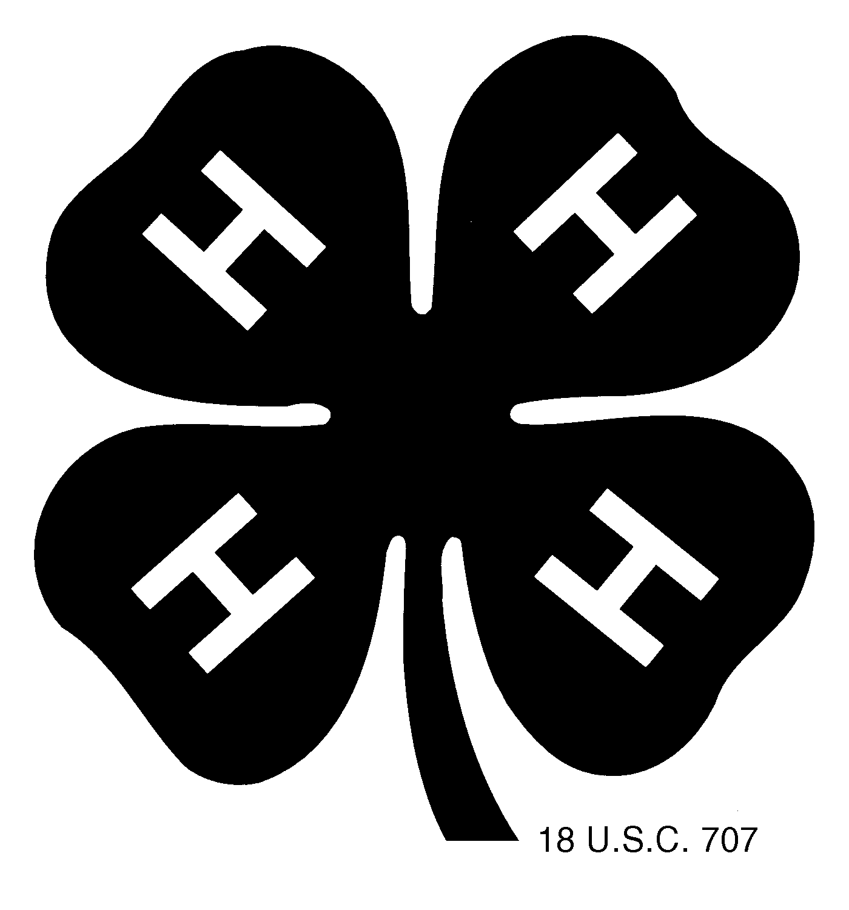

Pledge:
I pledge-
My HEAD to clearer thinking,
My HEART to greater loyalty,
My HANDS to larger service, and
My HEALTH to better living,
For my club, my community, my country
and my world.

Motto:
“To make the best better!”

Colors:
Green and white

Issued in furtherance of cooperative extension work in agriculture and home economics, Acts of May 8 and June 30, 1914, in cooperation with the U.S. Department of Agriculture, Charlotte V. Eberlein, Director of University of Idaho Extension, University of Idaho, Moscow, Idaho 83844. The University of Idaho provides equal opportunity in education and employment on the basis of race, color, national origin, religion, sex, sexual orientation, age, disability, or status as a disabled veteran or Vietnam-era veteran, as required by state and federal laws
Revised: 10/09

